**Wall-Mounted Black Metal Bar Shelf With Mirror**

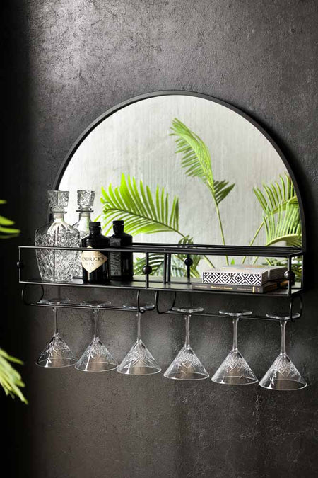The **Wall-Mounted Black Metal Bar Shelf With Mirror** is the perfect blend of functionality and modern design. Featuring a sleek black metal frame, this piece combines a spacious shelf for storing bar essentials with a full-length mirror, making it an ideal addition to home bars, kitchens, or even bathrooms. The clean lines and minimalist design ensure it complements any contemporary decor, while the mirror adds depth and light to your space. Whether you're looking to organize your drinks or create an elegant focal point, this stylish and practical wall-mounted shelf offers both utility and sophistication.